INS3121
SOIL MECHANICS
MAKE-UP EXAM
December 25th, 2015
Q.1 | Q.2 | Q.3 | Q.4 | Q.5 | TOTAL
Student Name Surname:
Number:
Group:
- Sieve analysis test results of soil specimens are given in the following table and figure for A, B, and C soils;
a) Calculate the coefficient of uniformity (C_{u}) and coefficient of curvature (C_{c}) of soils. (12p).
b) Classify these soils considering “Unified Soil Classification System (USCS) (8p).
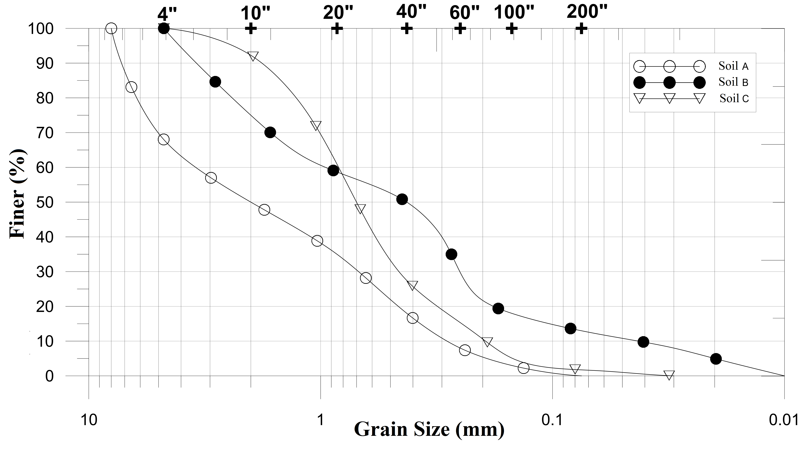
Sieve No | A | B | C
4 | 68 | 100 | 100
10 | 50 | 75 | 92
20 | 35 | 60 | 65
40 | 18 | 51 | 25
100 | 3 | 15 | 7
200 | 0 | 11 | 3
Liquid  Limit % | NP | 56 | 60
Plastic Limit % | NP | 25 | 35

- A flow net under a sheet wall lying on a permeable soil over impermeable layer is given figure. A 12 cm high and 5 cm diameter soil sample is placed in the constant head hydraulic conductivity test to determine permeability coefficient of the sandy silt soil. A volume of 15 cm³ of water over a time of 5 minutes has been collected in the container (Δh=25 cm). Based on this information:
- Determine the discharge velocity and seepage velocity of the sandy silt soil. ( e=0,45) (10p).
- Calculate the amount of water seepage under the sheet pile wall per its unit width (5p).
- Determine whether there is a quick sand condition at the point B or not (5p).
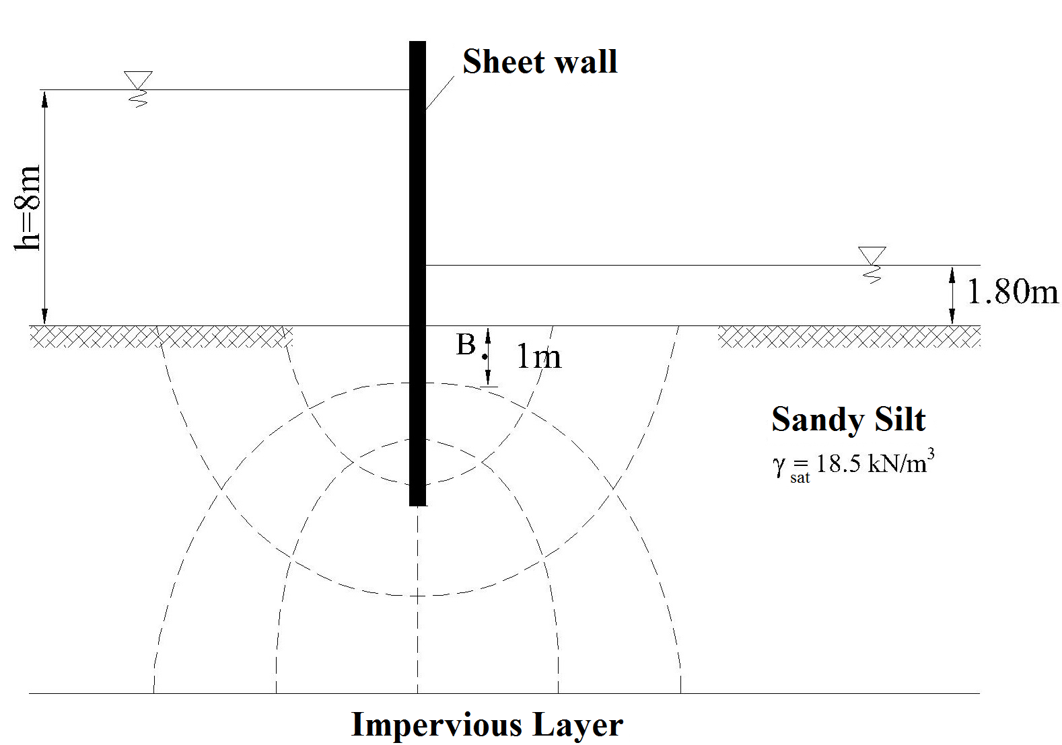

- An oil storage tank with a diameter of 35 and 15 m height will be constructed on the soil profile in the below figure.
a) If the preconsolidation pressure (σʹ_{p}) of the clay layer is 200 kPa, compute the settlement that will take place underneath the center of the tank due to primary consolidation of the clay layer. (Effective vertical stress increment due to oil storage tank is (Δσʹ) 75 kPa.) (15p).
- An oedometer test was performed on a clay sample recovered from the clay layer and coefficient of consolidation c_{v} is obtained to be 0.04865 cm²/min. Determine the time required for 90% consolidation to take place in the field (5p).
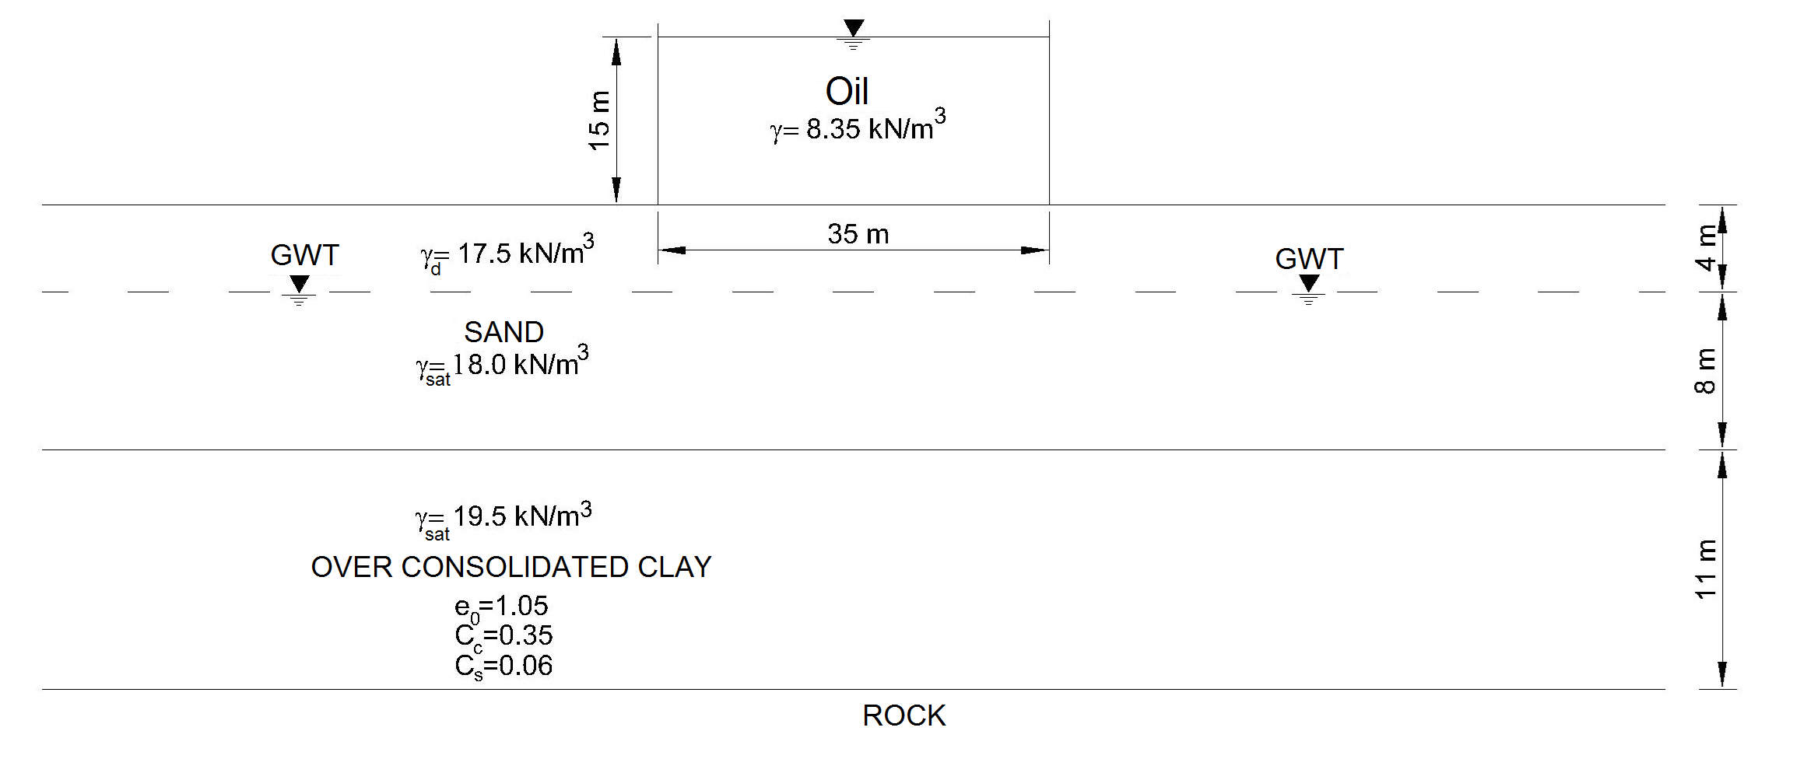
U (%) | 10 | 20 | 30 | 40 | 50 | 60 | 70 | 80 | 90
T_{v} | 0.008 | 0.031 | 0.071 | 0.126 | 0.197 | 0.287 | 0.408 | 0.567 | 0.848
- The results of triaxial tests performed on disturbed and undisturbed clay soil samples are given in the below table:

Test | Cell Pressure (kPa) | Deviatoric Stress (kPa)
1.CD | 100 | 90
2.CD | 200 | 150
UU | 150 | 80

a) Compute the drained shear strength parameters of the clay soil (10p).
b) Determine whether the soil is normally consolidated or overconsolidated clay according to the results obtained from the CD test (5p).
c) Plot the Mohr Circle and failure envelope for the UU test at failure and determine the undrained shear strength parameters of the soil (5p).

- a) What is the hydraulic gradient? Explain briefly. (5p).
b) What is the over consolidation ratio? Which value can be taken for normally consolidated clays and over consolidated clays? (5p).
- Briefly describe the unconfined compression test. (5p).
- Explain briefly the term of capillarity. (5p).

Time is 90 minutes. Good Luck…

